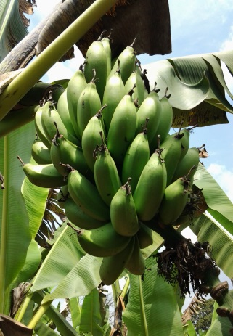 |  | 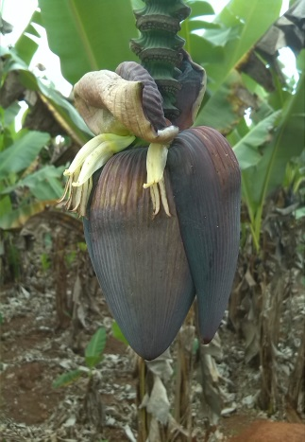 |  | 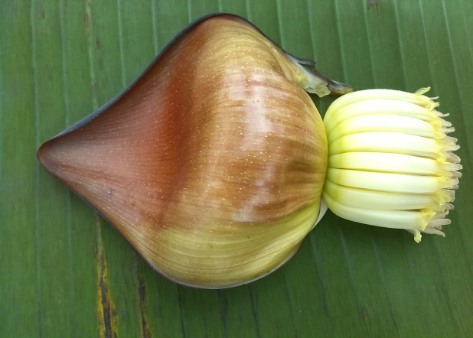
Kazirakwe bunch |  | Purple-brown bract external face |  | Orange-red colour of bract internal face and cream compound tepal
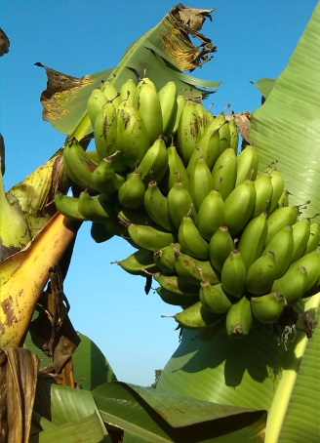 |  | 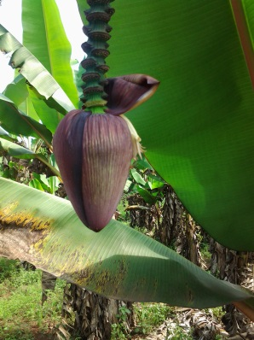 |  | 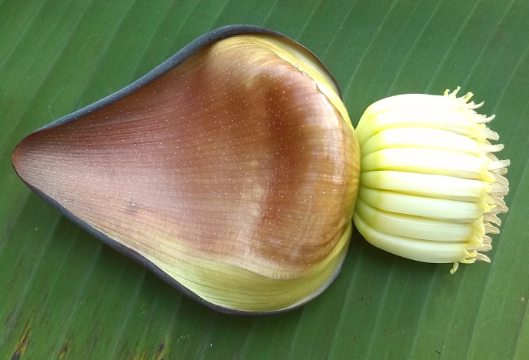
Nakasabira bunch |  | Purple-brown bract external face |  | Orange-red bract internal face and cream compound tepal
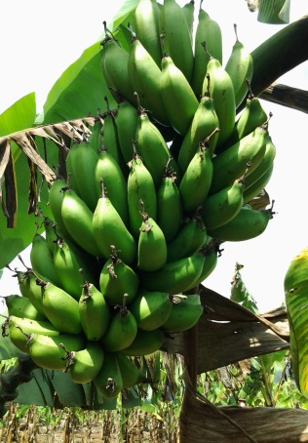 | 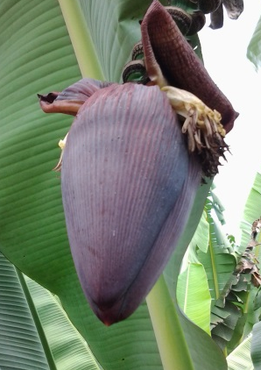 |  | 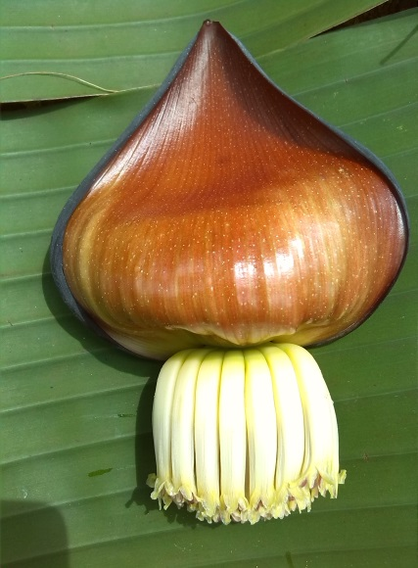
Nakayonga bunch | Purple-brown bract external face |  | Orange-red bract internal face and cream compound tepal
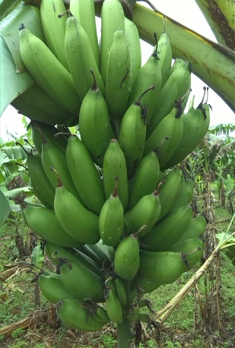 | 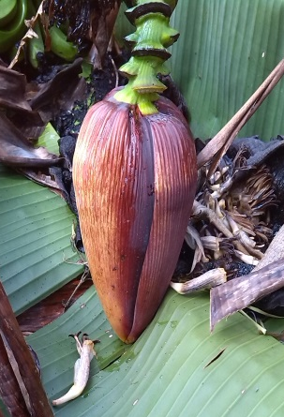 |  | 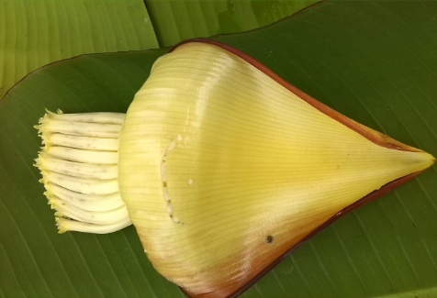
Nakyetengu bunch | Purple brown bract external face |  | Orange-red bract internal face and cream compound tepal
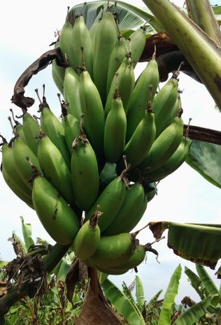 | 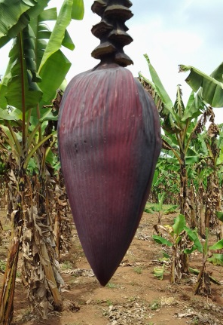 |  | 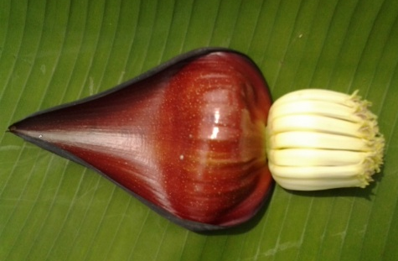
Entukura bunch | Red-purple bract external face |  | Red bract internal face and cream compound tepal
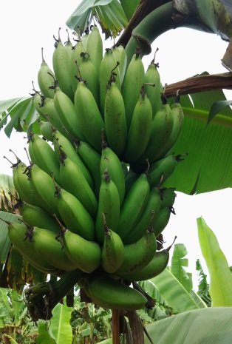 | 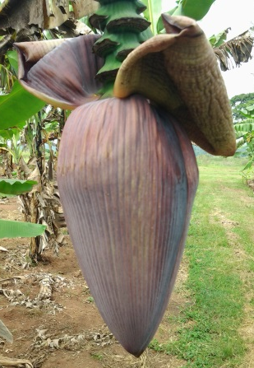 |  | 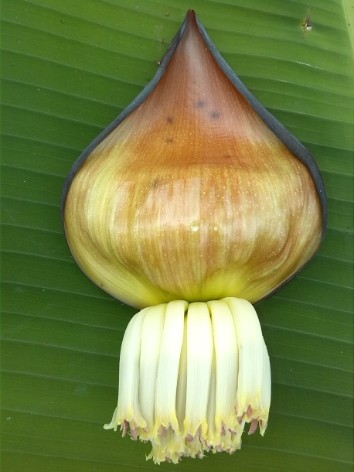
Enyeru bunch | Purple-brown external bract face |  | Orange-red bract internal face and cream compound tepal
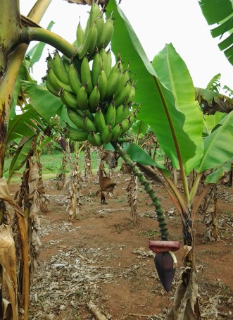 | 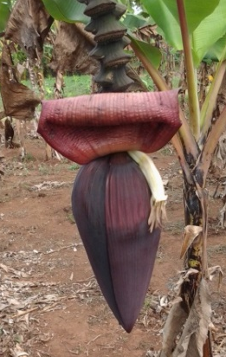 |  | 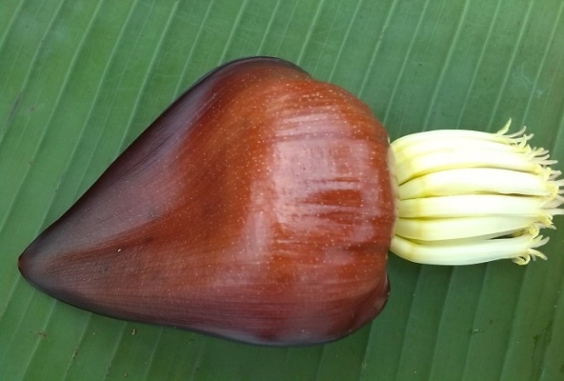
Enzirabahima bunch | Red purple external bract face |  | Red internal bract face and cream compound tepal
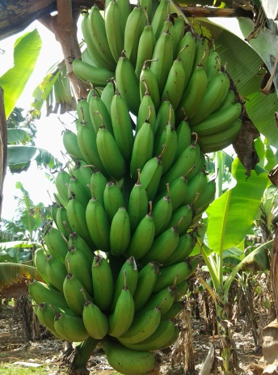 | 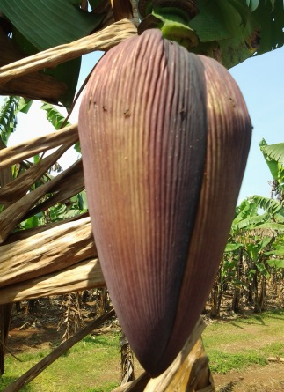 |  | 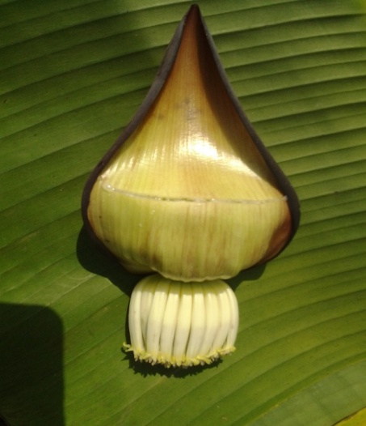
Kabucuragye bunch | Purple-brown bract external face |  | Orange-red bract internal face and cream compound tepal
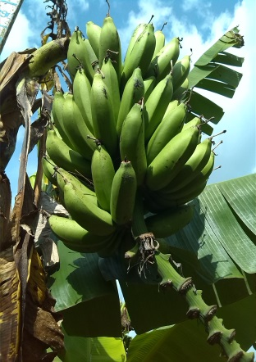 | 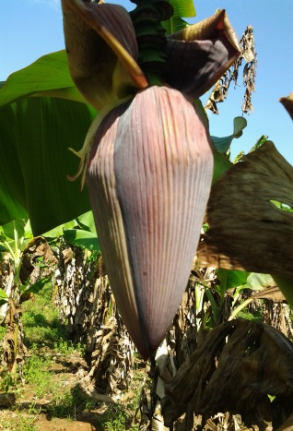 |  | 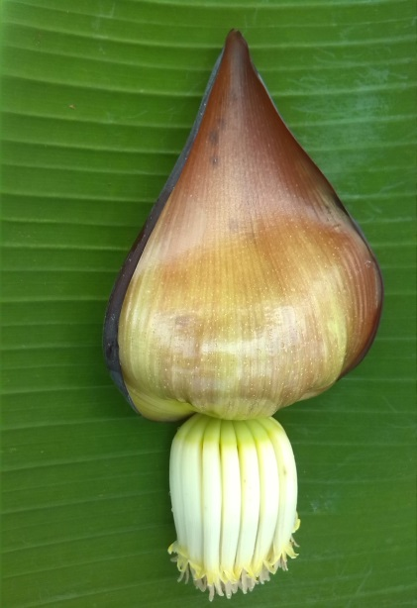
Namwezi bunch | Purple-brown bract external face |  | Orange-red bract internal face and cream compound tepal

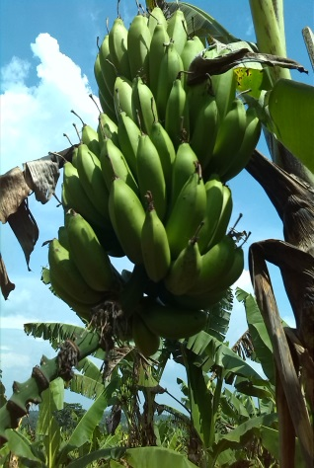 | 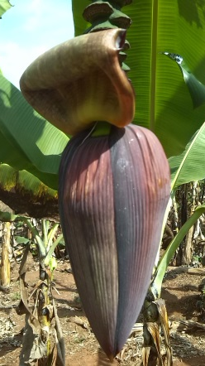 | 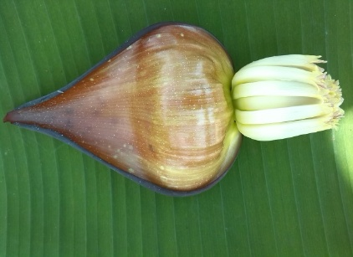
Nfuuka bunch | purple-brown bract external face | Orange-red bract internal face and cream compound tepal

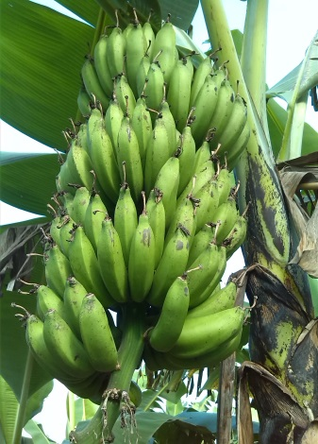 | 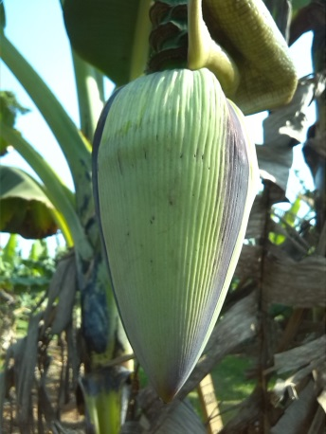 | 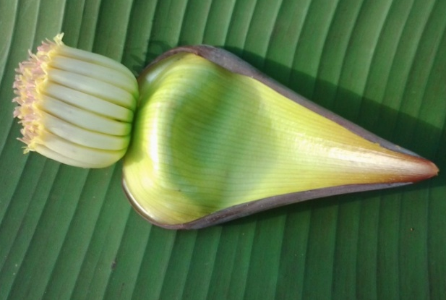
Tereza bunch | Light green with purple stripes of bract external face | Yellow or green with orange-red towards the apex of bract internal face

Fig.S1 Pictures of the eleven ‘matooke’ cultivars used in verifying the minimum set of Musa descriptors (Online Resource 1)

