An organizational perspective on Human-Centered Design for inclusive innovations
Anna Müller ^{1, 2, a} , Jonathan Steinke ^{1, 2} , Hugo Dorado^{3,4}, Salome Keller⁵, Daniel Jimenez^{1,2} , Berta Ortiz-Crespo^{1,2}, Charlotte Schumann⁴,

¹ The Alliance of Bioversity International and CIAT, Montpellier, France
² CGIAR Initiative on Digital Innovation, c/o International Food Policy Research Institute, Washington D.C., USA
³ Mathematical and Statistics Methods, Wageningen University
4 Plant Production Systems, Wageningen University
5 Systemic Human-Centered Design Consultant, Stuttgart, Germany
6 Freie Universität Berlin, Berlin, Germany
a corresponding author: a.muller@cgiar.org

Date 23/10/2023

Work package Digital Inclusion

Table of Contents
Highlights 2
Abstract 3
Introduction 5
Background: 8
Data and methods 10
Results 13
Discussion and conclusions 21
Acknolwedgements 25
Funding 25
Bibliography 26

** This is a non-peer reviewed preprint. The article is currently under review for publication. The final version of this article might be different to this version.

Highlights
- Human-Centered Design (HCD) is applied for inclusive innovation design and is increasingly popular in agricultural research for development.
- HCD outcomes are influenced by organizational context. We analyze HCD maturity, organizational enablers and challenges in the case of CGIAR
- We find that HCD maturity in CGIAR is low: attitude towards HCD is positive, but organizational strategy and processes are not established.
- Enablers are digital transformation and motivated researchers. Challenges are a technocentric research paradigm and funding mechanisms.
- We recommend a set of actions, show advantages and limitations of HCD and discuss the technocentric research paradigm.

Abstract
Human-Centered Design (HCD) is increasingly integrated into international research and development in order to develop more inclusive digital innovations. This is also a trend we observe in the CGIAR portfolio. This study explores the organizational patterns influencing the effective implementation of HCD in CGIAR. The research employs a framework adapted from organizational UX maturity assessment and combines survey responses and expert feedback. Findings reveal CGIAR's low organizational maturity, indicating limited implementation, particularly in strategy, processes, and outcomes. While there is general openness to HCD, strategic integration is lacking, with minimal budget, little established processes, and poor documentation of outcomes. Key enablers include external drivers, research curiosity, familiarity with social science, and initial processes. Challenges arise from donor pressure, technological determinism, and misconceptions about HCD. In a more mature state, experts envision cross-functional teams, valuing collaboration and continuous user interaction. Recommendations for enhancing HCD maturity at this stage are discussed, emphasizing the broader implications for non-profit agricultural research organizations facing similar challenges. Understanding the possibilities and limitations of HCD is crucial for fostering more inclusive innovations within CGIAR and beyond.

Introduction
Agricultural research for development (AR4D) has often been criticized for being too technology-centric. Too often, the design of innovation was driven by what is technologically possible rather than by what was needed. However, evidence suggests that this approach frequently falls short of producing innovations that are genuinely user-centered, inclusive, efficiently addressing the underlying problems and sustainably adopted by the target group (von Hippel, 2005). Innovations that are generated mainly on the basis of technical feasibility carry the risk of adoption failure, as they may disregard actual needs, context, and target group behaviors (Dodson et al., 2012; Eastwood et al., 2019; Krell et al., 2021; Masiero, 2016; McGrath et al., 2023). Often, technologies are designed for a supposed ‘average’ user and fail to consider the diversity of needs of more marginalized groups, like women, indigenous people, elderly and disabled people (Oudshoorn and Punch, 2008; Steinke et al., n.d.; Waller et al., 2015)
In response to this, researchers are progressively seeking methods to design innovations that are guided by user needs, behaviors, and contextual factors. This extends to embracing a diverse range of potential engagements with and usage of innovations, encompassing aspects such as gender, language, age, and ethnicity. Particularly within the area of digital agriculture, we see an increase in interest in process-oriented methodologies, including approaches like human-centered design (McCampbell et al., 2022; Ortiz-Crespo et al., 2021; Steinke et al., 2022). Following the definition proposed and made popular by (IDEO, 2014), HCD is a creative, iterative and open-ended approach to problem solving to find solutions that improve people’s lives. Human-centered design is seen as one important cornerstone in the process of designing fit-for-purpose and inclusive innovations tailored for the agricultural sector in the Global South (Coggins et al., 2022; Holmes, 2020; Steinke et al., n.d.)). There are more benefits associated with a focus on HCD. An emphasis on user-centricity, continuous iteration, collaborative cross-functional teams, and strategic design leadership empowers organizations to innovate their products and services in ways that resonate more effectively with users compared to their less design-mature competitors (InVision, 2019; McKinsey, 2018). This can generate cost savings and productivity increases: design decisions can be corrected early in the design cycle and user support for deployed products can be reduced. Innovations that are designed with a focus on inclusion can reach a broader user base and improve user satisfaction (Waller et al., 2015). On the contrary, low design maturity means uncoordinated design efforts (and often related: unsuccessful products), limited financial and human resources, and a lack of leadership endorsement - factors that limit the potential of design approaches (Mani-Kandt and Robinson, 2021; McCampbell et al., 2021).
Human-centered, and related approaches following a Design-Thinking mindset as user-experience (UX) design and user-centered design, have a long tradition of being applied in the private sector. With the increasing popularity and a certain hype around design approaches, they come under increased scrutiny on whether it can deliver on what they promise for inclusive and human-centered innovations. The evidence on the outcomes of HCD in not-for profit research is still scarce. The application of the approach seems to be a good way of shifting the mindset towards a more empathetic, creative and open-ended way of working (Mani-Kandt and Robinson, 2021). It looks like it is working well for narrowly-framed problems, but there is no clear evidence yet on the impact on more large-scale, systemic problems like inequality or poverty (Mani-Kandt and Robinson, 2021). Funding and management mechanisms clash with the iterative mindset, and often, HCD teams are not able to address aspects beyond user-centeredness, like feasibility, viability or scale, from the beginning of the process (Mani-Kandt and Robinson, 2021).
But what becomes clear from the current evidence, mainly from the private sector, is that organizational structures and routines are important factors that shape an organization's capacity to embrace and execute an approach as human-centered design effectively (Molich et al., 2020). This extents from budgeting and research management to attitude, leadership support and organizational goal setting (Sauro et al., 2017). The organizational HCD maturity affects how sophisticated and effective an organization approaches user experience and human-centered research, design, and implementation. The maturity level reflects how the organization understands, adopts, and integrates principles, processes, and practices throughout the innovation development process (Molich et al., 2020).
An organizational framing of pressing problems as climate change and food insecurity as purely technological challenges can limit the potential of HCD in crafting inclusive innovation processes. To systematically comprehend the possibilities and constraints of HCD in AR4D to deliver fit-for-purpose and inclusive innovations, a thorough understanding of the organizational context and maturity is important. This understanding is not only important for setting realistic expectations but will also allow making tailored recommendations for how to further increase HCD maturity.
The focus on product design am development is just recently finding its way into the AR4D sphere. Researchers are used to waterfall management approaches and not to follow a product development approach, research is usually focused on filling knowledge gaps and not on informing product design, and the research follows funding cycles and is influenced by donor and stakeholder demands.
We assume that this creates a particular setting enabling the use and realizing the potential of HCD for inclusive innovations. The “productization” of research does not come without tensions, and it is not clear yet whether the concept of HCD is something that can fully be integrated into agricultural innovation research as it is for example in digital product firms.
It is thus quite important, considering the current increase in HCD, to generate a more systematic understanding of organizational enablers and challenges for HCD. To bridge this gap, we are looking at the CGIAR as one of the most important AR4D organizations and intend to answer the following questions:
What constitutes the present level of HCD maturity within the CGIAR centers?
What are the prevailing pain points, challenges, and enablers for the implementation of HCD?
And how could a more HCD-mature CGIAR look like?

Background:
Human-centered design is a creative problem-solving approach that puts the needs, behaviors and living context of humans at the center of the solution finding process (IDEO.org 2015). HCD focuses on understanding and addressing the needs and behaviors of users through iterative cycles of research, ideation, prototyping, and testing to create solutions that are intuitive, useful, and enjoyable for users. While the recent hype around HCD in AR4D is strongly driven by the digital agriculture trends, its application goes beyond the digital sphere (e.g., IDEO.org, 2015).
Human-centered design is crucial for enabling inclusive innovations. By putting the users at the center of the design process, human-centered design ensures that products and services are accessible, usable, and valuable to a wide range of individuals. It helps uncover and address barriers, biases, and exclusion factors, resulting in more inclusive and equitable innovations that can benefit a larger and more diverse user base (Holmes, 2020; Steinke et al., 2022, n.d.; Waller et al., 2015). But the positive benefit of using a human-centered approach can be unclear, for example if there is little organizational human-centered culture and tradition. The open-ended approach creates uncertainty about the outcome and requires significant changes in innovation-research processes. Breaking down the barriers between users and innovation developers might clash with organizational cultures that are based on hierarchies and top-down processes.
There are common organizational challenges to the adoption of design approaches in organizations, stretching from the organizational culture and mindset to budget limitations, missing support and trust from colleagues and leadership and not enough training and expertise (Bergart, 2020). (Nielsen Norman Group, 2023a) describe in a more detailed model how organizational context shapes how effectively user experience (UX) design can be implemented. This 6-step maturity model describes an organization's ability for effectively practicing human-centered design and similar approaches (Molich et al., 2020; Sauro et al., 2017; Traynor, 2022). UX Design and HCD are related and overlapping concepts. UX Design focuses on the user, whereas HCD looks at people in general (Stepanov, 2022). Due to the closeness and connectedness of HCD and UX Design, we build in the following on the Nielsen UX maturity model and adapt it to our approach to HCD.
The model provides a structured framework for organizations to assess and understand their current state of UX practices. The focus lies on four areas: strategy, culture, process and outcomes and describes six stages of maturity (Nielsen Norman Group, 2023a).
The maturity model has some limitations that we acknowledge: UX maturity in an organization is complex, and the model might give a very simplified representation. In different teams, projects or departments of an organization different maturity levels might co-exist. The Nielsen maturity model has been developed for private companies in the digital product development and e-commerce sphere.

Data and methods
We analyzed the HCD maturity level of CGIAR. CGIAR, a global partnership for agricultural research, integrating 13 centers operating across Latin America, Africa and Asia (CGIAR, 2023). CGIAR is one if the global leaders in AR4D and is a good case study for understanding the organizational implications for the recent trend towards HCD in AR4D. We assume that the structures, culture, and context within CGIAR organizations are similar to other AR4D organizations and for thus this case study holds broader relevance for understanding organizational HCD maturity.
from the Nielsen UX maturity survey to fit our HCD approach (source, see questionnaire attached or supplemented). The Nielsen Norman maturity survey integrates a set of 13 questions with four to six categorical responses covering HCD mindset, HCD strategy, HCD processes and HCD outcomes. HCD culture considers organizational and leadership support for HCD; HCD strategy focuses on goal setting and resource prioritization; HCD processes looks at research and design process planning; and HCD outcomes is about how design impacts products and how this is measured. We adapted the set of questions to fit our approach to HCD.
Unfortunately, the analytics for the Nielsen UX maturity assessment are not publicly available, so it is unclear how exactly they estimate the maturity level of an organization. There is an online mask where a self-assessment is possible (Nielsen Norman Group, 2023a). We estimated the maturity level as follows: for each question, we estimated the mode of each response value. Then we estimated the group mode across the different questions to reach the estimate of the organizational maturity level.
For validity check, we entered a few observations in the online mask of the assessment, the result equals the one we estimated.
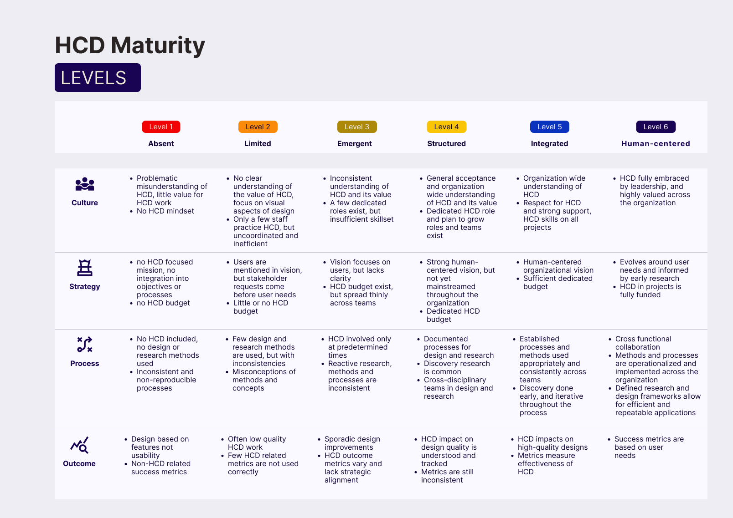
We sent the survey to a non-random sample of 90 researchers and research support staff across different CGIAR centers. We contacted all employees and consultants affiliated with two CGIAR Initiatives: The Initiative on Digital Innovation, where we expected a relatively high level of HCD maturity, and the Initiative on Excellence in Agronomy, where we supposed maturity to be lower. We received a total of 24 responses. From these, we considered 23 for the analysis.
Figure 1 Levels of HCD maturity (adaptation from Nielsen Norman Group, 2023a)

To further understand challenges and enablers and get an idea of a more HCD mature organizational scenario, we created a virtual space in mural (Mural, n.d.). We invited 5 internal and external HCD experts to leave their comments and perceptions for each of the topics. We purposefully selected people that we knew had experience in implementing HCD in projects inside and outside the CGIAR. Several of the experts are part of the author team.
We clustered the results of this expert consultation in various iterations. This allowed us to identify the main topics describing enablers and challenges for HCD implementation in CGIAR. The same way we clustered the comments mentioned to understand how a more HCD mature CGIAR could look like from an expert perspective.

Results
HCD maturity assessment
- Status quo:
The overall maturity level estimated of the survey results is 2. Following the proposed model at this stage, organizations are described as uneven, haphazard and aspirational (Nielsen Norman Group, 2023b). Following the Nielsen model, at stage 2, organizations mention users in their vision but prioritize shareholder or donor requests over user needs, with sporadic funding and awareness for human-centered processes. There's a vague understanding of HCD, yet misconceptions persist. Basic methods are used with design inconsistencies due to a lack of shared tools. HCD work, though present, lacks quality due to limited resources, and metrics are often misused.

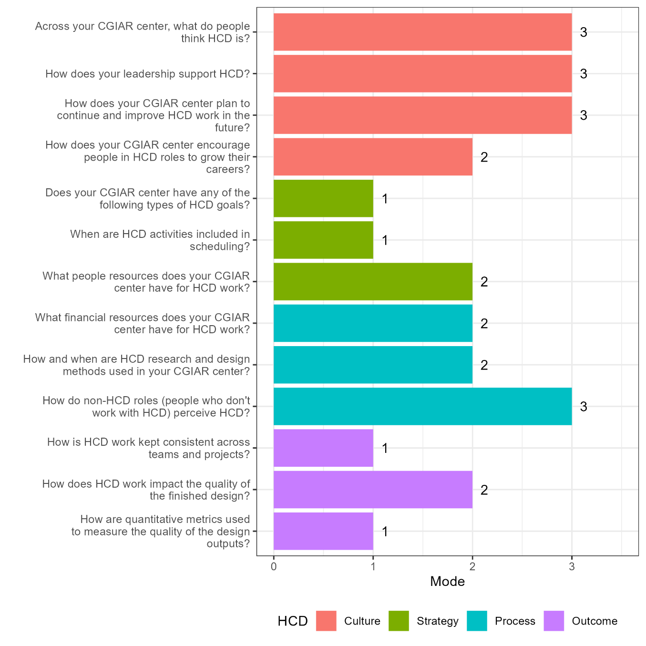
Figure 3 Maturity score per question (mode)
The median score of the response values for each question across the four sections gives a more detailed picture. The higher the score, the higher the maturity in each of the questions. Questions related to culture, like perception, and organizational support score highest with 3. There is increasing awareness of the value of an HCD approach and researchers in CGIAR start to embrace a human-centered mindset. The questions related to strategy and outcome scored lowest in our survey: there are no HCD-specific organizational goals and HCD activities are not included in the scheduling as it should be. HCD work is not kept consistent across teams and projects and no metrics are used so far to measure the quality of the design outputs.
HCD is increasingly recognized and valued across the organization, but there is no strategical embeddedness of the approach, nor are there yet strong consistent impacts. Resources are still spread very thinly; efforts depend on one or a few people. Processes and methods are not consistent, and metrics are almost not used. The increasing awareness but lack of strategy, processes and outcomes is typical for organizations at this maturity level (Nielsen Norman Group, 2023b).

- Enablers and Challenges for HCD
To get a more nuanced understanding of organizational enablers and challenges of HCD in CGIAR, we base our analysis on the perceptions of HCD and AR4D experts. Using their insights, we clustered the enablers and challenges into four main groups: 1) external factors, 2) Methods and concepts, 3) Mindset and values, 4) HCD operations and management. Several aspects were mentioned as both being enablers and challenges. Highlighting that there is not one such thing as HCD maturity, but it depends on different organizational, project, and team related aspects..
For the drivers and enablers of HCD we highlight the following aspects:
1) External drivers and enablers of HCD
One important enabler and driver for the integration of HCD into research-based innovation processes has been the global trend towards a digital transformation in the agri-food system. Evidence is increasing that the adoption of digital and technology driven innovations has not been as expected. At the same time, there's more pressure from supporters and funders to prove that the research is making a difference. HCD is seen as a solution towards producing more fit-for-purpose solutions that are adopted at scale and reach a desired impact.
According to the consulted experts, some of the donors are open to trying out new and flexible ways of coming up with ideas and have a good understanding of the type of wicked problems agricultural research is trying to address. CGIAR researchers are creating a growing number of examples and experiences where HCD has worked. These success stories help to make people support HCD.
2) Mindset and values
Another set of enablers highlighted by the HCD experts is the mindset and values of CGIAR researchers. The research background of the scientists enables the use of design approaches: scientists know how to validate concepts and have a good knowledge of statistics and data analytics, part of the scientists has a good understanding of qualitative research.
In the CGIAR prevails an interdisciplinary and innovative mindset that enables the application of HCD in the organization: multi-disciplinary teams are very common, and most researchers are used to working with scientists from other disciplines. Scientists are open to testing new ideas and have a certain liberty of trying out new things.
Another enabling factor highlighted by the respondents is the supportive peer network of creative and engaged colleagues on which researchers can rely on. People in CGIAR are used to working in an international environment and tend to have an intercultural mindset and sensitivity and empathy for cultural differences. This helps to embrace the HCD mindset.
Several of the consulted experts highlighted the increasing support from people in leadership positions at the executive level, research initiative leads, and from direct supervisors of researchers as an important enabler for HCD in the CGIAR.
3) Methods and concepts
The consulted experts consider the existing research expertise a strong enabler for HCD. CGIAR researchers, especially those with a social science background, have prior experience with qualitative research, know how to formulate a proper, testable hypothesis, and are used to working with validation methods and statistics.

4) HCD operations and management
Another set of enabling factors lies in how HCD is operated and managed. In the research environment of CGIAR, research time is routinely planned for in projects; using validation and testing techniques is also common. This suggests that the uptake of more systematically iterative design methods will not strongly clash with current habits. One of the consulted experts with a private sector background highlighted that iIn a non-research environment, low HCD maturity organizations often face difficulties integrating time for research in their projects.
There are already some existing roles, e.g., user research or design experts, filled either by staff or consultants, which enables the use of HCD.
- Challenges for HCD
The consulted experts mentioned significantly more aspects that challenge effective HCD in the CGIAR organizational context. This might reflect the relatively low maturity in the organization. Among the challenges we highlight the following:
1) External drivers
Consulted researchers perceived the donor expectations to deliver pre-defined solutions as a strong challenge for open-ended and iterative design processes. Solutions often have to be defined at the proposal stage which is contradictory to the open-endedness of the HCD process.
2) Research mindset and values
The prevailing technological determinism in AR4D came out as a strong challenge for HCD. Solutions often narrowly focus on specific technologies, especially in digital agriculture (“Let´s make an app and use AI”), neglecting the multiple entry points solutions could have for a problem. This contradicts the openness of an iterative design process.
Aspects of the prevailing research mindset and research routines, that favor the use of quantitative and standardized methods, are considered as challenges for HCD: for some respondents, creativity is not an institutional value per se, and people perceived that the missing culture of experimentation presents a challenge to HCD, limiting openness of researchers to discard already created solutions. This can be a personal attitude of researchers, that probably also reflects an organizational culture that makes it difficult to admit that one was wrong with an initial assumption.
Some of the consulted experts seem to perceive a tension between the notion of science as a means to explore and push the boundaries of what we know and can do, and the concept of user-centeredness, that focuses on real needs. They perceive that this focus limits the potential of exploring groundbreaking innovations.
Although scientists are used to validating and testing, the focus is on testing advanced prototypes or already deployed products instead of hypotheses and concept testing, which can be considered a challenge towards becoming human-centered and inclusive in the innovation process.
3) Methods and concepts
Regarding methods and concepts, the respondents highlighted a few aspects that can be considered challenges for effective HCD implementation: There seems to be a lot of unclarity among the researchers about what HCD actually is. Some researchers seem to have the impression that HCD means to be driven entirely by user desires and ignore own expertise, knowledge, and technological possibilities.
The experts perceive that some researchers reject or belittle HCD as they assume it is only for creating nice visuals. The perception is that caused by superficial knowledge of design and user research methods, and unskilled application, the true value of HCD methods often remains hidden.
Respondents perceive a method-competition as a challenge for HCD: researchers seem to think in either-or schemes: either gender research or HCD; either participatory research or HCD; there seems to be little integration of different approaches.
Respondents also discussed a certain “method fatigue” that can be a challenge for HCD: Scientists are constantly confronted with new approaches and methods, some are hypes that come and go, others stay. There is an expectation of implementing this on top of the already ongoing research projects. This reduces the incentives for research to engage or enable new approaches.
- How might a more mature CGIAR/AR4D setting look like?
We asked the expert respondents how they would imagine a scenario of a more HCD mature CGIAR and an organizational context that allows HCD to fulfill its potential for more inclusive innovations. Again, through iterative clustering, we identified several aspects that could identify a more HCD mature CGIAR. The body of the comments address HCD management, processes, and outcomes. We used the results to construct a future scenario for a more HCD mature CGIAR.
In the HCD mature CGIAR, innovation projects are designed open-ended, and the problem definition is done through discovery research together with the affected or targeted people. Project planning considers the design phases and the iterative nature of the HCD process. To support their teams on every step of the human-centered approach, the HCD operations and management team has introduced streamlined processes: there are generally acknowledged guidelines and principles for HCD implementation. The value of HCD for inclusive innovations is generally accepted. Research- and Design-Ops manager facilitates and supply researchers with the tools they need, while product owners steer multi-disciplinary teams to successful innovation design. Design ops provide everything designers need to create consistent quality designs. Ideally, user research is a key requirement for quality research and innovation development demanded by donors. Calls for proposal embrace a more human-centered approach and do not demand the solution, by specifying a target group and not the concrete problem.
Cross-functional teams naturally integrate social scientists and designers, as well as tech-experts and developers. Every CG scientist is used and trained to work in diverse teams and roles are frequently (re-)defined and discussed, so they are known and lived by each team member. Product teams and research teams have clearly defined collaboration structures and tools. User researchers and designers integrate developers and subject matter experts in their discovery and ideation work, to show the potential of user interaction. User researchers are standard members of the innovation teams. Revising design decisions is culturally appreciated.
In order to explore the problem before defining it, budget is allocated to the design phase of each CGIAR project. Human-centered research and design budget is secured by organizational core funding. There are enough permanent staff positions to allow for user interaction and follow-up also after project cycles have finished. HCD professional networks in the CGIAR are strong and visible, and regularly iterate and adapt HCD processes and concepts to the needs of the AR4D community. CGIAR is a thought leader in the field of human-centered design for agricultural development and cooperates with other players to develop tools, training, and showcases.
In this more HCD mature scenario, there is a clear understanding of HCD, UX and user-centered design and its value. The organization has embraced a more human-centered mindset that goes beyond product design: for example, the design of organizational policies and regulations does embrace a human-centered mindset.

Discussion and conclusions

We show that the HCD maturity level in CGIAR is relatively low. Stage 2 maturity means that the use of HCD for inclusive innovation design is still very limited in the organization and is more integrated into the culture than in processes and outcomes. Certain aspects of the CGIAR organizational culture are strong enablers for HCD. External drivers and a general trend towards a more needs-based, problem-focused, and human-centered mindset push the interest in HCD. An innovative, curious, and exploratory internal culture and existing research processes are fertile ground for the approach.
Current attitudes and capacities of out-of-box-thinking are a good precondition for more HCD, but these attitudes need to be nurtured more strongly to successfully implement HCD at higher maturity levels. Respondents perceive that misconceptions and prejudices prevail that either oversell or belittle the value of HCD. No systematic HCD research and design processes exist, which makes it often difficult to realize the intended impact of HCD. It is important to note that there is not such a thing as one maturity level in the CGIAR. Although the individual responses in the survey did not show a strong variation, the maturity does differ between CGIAR centers, teams, or projects.
Concrete recommendations for increasing HCD maturity at this stage, following the framework developed by (Nielsen Norman Group, 2023a), are focusing on mindset and culture and on improving human-centered research and design processes. A big limiting factor at this stage is the lack of a clear understanding of concepts and methods across the organization. Efforts should go into creating a common understanding of concepts, methods, and the value of HCD. This could be done through seminars, but also through offering thematic check-in with experts and practitioners. It is good to focus on a set of strategic projects that will have a good impact. HCD teams should invest time in applying human-centered research and design methods correctly and aim for integrating new methods into their HCD portfolio. First efforts can go into harmonizing HCD tools and concepts across teams and projects.
We think that a rethinking of what users are in the CGIAR context can be further useful at this stage of HCD maturity in order to make design processes more inclusive. It is not always clear which users are targeted in a design process, and the line is often blurry between those who directly use the tools (end-users) and those who are indirect users (demand partners like ministries or NGOs) or have additional interests in the tool (e.g. donors or researchers). This involved paying strong attention to representation and power structures between different types of user groups (Oudshoorn and Punch, 2008). In order to have users and the people we design for as agents of change we have to rethink our relationship with them. (von Hippel, 2005) for example recommends forming partnership with lead users, for example by establishing so called “Innovation communities”, where users and innovators can openly share and exchange ideas and information. These “Innovation communities” can be either virtual or in-person. HCD could also broaden it´s perspective and embrace a more systemic and relational perspective to consider for example the digital ecosystem, but also consider balancing the human-centered perspective with a perspective on the needs of nature and biodiversity.
We want to discuss two of the identified challenges in more detail, namely method competition and the technocentrism of CGIAR research. These reflections hold relevance for the broader agricultural research sectors. We think our analysis holds relevance beyond CGIAR: interest in HCD for inclusive (digital) innovations is increasing in other organizations of the AR4D organizations (McCaig et al., 2023) and others)). Funding structures and research-based innovation processes are similar. The trend towards HCD is recent, so the maturity stage in the AR4D sector will be similar.
The observation of a perceived method competition in the CGIAR draws our attention. Maybe this aspect differentiates the implementation of HCD from other sectors. Competition in research around discoveries and results and its impact on research quality and collaboration are widely discussed in the research community (Stein and Hill, 2021). Our observation leaves the impression that researchers perceive different (mostly process-based) methodologies as competing with each other and with HCD, naming e.g., participatory research, gender research, scaling, or systems thinking. This may reflect two aspects. First, there is strong competition around bilateral funding, and researchers’ reputation withing the CGIAR is (strongly) based on scientific merit in a certain thematic or methodological area. The appearance of new, often similar approaches might at first sight increase the (perceived) competition around funding. Second, researchers are often overwhelmed with multiple request to their roles: they are not only agronomists, but should know about gender research, should be innovation managers etc. The multiple expectations that researchers see themselves confronted with might cause resistance towards new approaches. If people are motivated to train themselves in new methods and this should become part of their official job profile.
We strongly recommend fostering an open mindset in research teams. It would be great to see the creation of open spaces to discuss the differences and complementarities between different approaches, e.g., Systems Thinking and Design Thinking, Scaling and HCD. It should be avoided promoting different schools as individual silver bullet solutions. There are strong complementarities between these types of approaches. This reflects better the AR4D reality that most of the time addresses wicked problems.
The current trend towards human-centered, open-ended, and iterative approaches like HCD has a deeper rooting in relation to the current research paradigm in AR4D. This paradigm is still strongly focused on technological determinism and a linear understanding of innovation adoption, as expressed in the narrative that persists around the green revolution (Van Etten, 2022) and the current narrative that is built around the transformative power of digital agriculture (Rose et al., 2023). Technological determinism describes an understanding of technological innovations and development that happens disconnected from social, economic and political context, pushed by a design paradigm building on technological logic (Wyatt, 2008). The other important assumption of this research paradigm is that social change follows technological change (Wyatt, 2008). Technology studies have challenged this worldview (prominent examples are (Latour and Woolgar, 1986; Marx and Smithq, 1994) amongst many others). This mindset leaves little space and responsibility for considering human or other relational aspects (environment, politics, inclusion) in innovation design. Technological determinism will not disappear (Wyatt, 2008). So what to do to triangulate the different views on technological innovation and societal change?
(Wyatt, 2008) recommends an approach in line with HCD: try to understand the need for a simplified idea of technological development and societal change. For CGIAR, this could mean for researchers from different disciplines to create a space where a critical reflection on technological development and societal change can take place. This could include reflections on our current research paradigm and how it shapes our interpretation of research results and technological possibilities. Also a critical reflection on approaches as HCD will be healthy: the use of process-oriented and human-centered approaches will not revolutionize how we develop innovations and will not automatically result in technologies with higher adoption rates and more inclusive features (Weaver, 2020). Our research emphasizes the role of organizational context in determining how effective HCD can be applied for inclusive innovations. We see definitely the need to further push the boundaries of our understanding of what works and not and in which contexts: By understanding how organizational context, research paradigms, and narratives shapes how we produce technology for societal change we can move a step forward in building truly inclusive and democratic innovations. HCD can be one important cornerstone for this process towards a more balanced view on innovation processes (von Hippel, 2005) .
We envision a research environment where we have a with a grounded and empathetic understanding of the contributions and limits of each discipline and being more humble in terms of the transformational potential of technologies and processes.

Acknolwedgements
We thank Juan Manuel Arías and Emmanuel Zapata for their support with this research project.

Funding
This publication has received support by the CGIAR Research Initiative on Digital Innovation. Any opinions expressed here belong to the authors and are not necessarily representative of or endorsed by CGIAR. We thank all funders who supported this research through their contributions to CGIAR Trust Fund.

Bibliography
Bergart, R.M., 2020. Can User Experience Research Be Trusted? A Study of the UX Practitioner Experience in Academic Libraries. Weave: Journal of Library User Experience 3. https://doi.org/10.3998/weave.12535642.0003.201
CGIAR, 2023. CGIAR: Science for humanity’s greatest challenges [WWW Document]. URL https://www.cgiar.org/ (accessed 9.12.23).
Coggins, S., McCampbell, M., Sharma, A., Sharma, R., Haefele, S.M., Karki, E., Hetherington, J., Smith, J., Brown, B., 2022. How have smallholder farmers used digital extension tools? Developer and user voices from Sub-Saharan Africa, South Asia and Southeast Asia. Global Food Security 32, 100577. https://doi.org/10.1016/j.gfs.2021.100577
Dodson, L.L., Sterling, S.R., Bennett, J.K., 2012. Considering failure: eight years of ITID research, in: Proceedings of the Fifth International Conference on Information and Communication Technologies and Development, ICTD ’12. Association for Computing Machinery, New York, NY, USA, pp. 56–64. https://doi.org/10.1145/2160673.2160681
Eastwood, C., Klerkx, L., Ayre, M., Dela Rue, B., 2019. Managing Socio-Ethical Challenges in the Development of Smart Farming: From a Fragmented to a Comprehensive Approach for Responsible Research and Innovation. J Agric Environ Ethics 32, 741–768. https://doi.org/10.1007/s10806-017-9704-5
Holmes, K., 2020. Mismatch. MIT Press.
IDEO, 2014. the Field Guide To Human-Centered Design.
InVision, 2019. The New Design Frontier [WWW Document]. URL https://s3.amazonaws.com/designco-web-assets/uploads/2019/01/The-New-Design-Frontier-from-InVision-012919.pdf?utm_campaign=Design%20Maturity (accessed 7.19.23).
Krell, N.T., Giroux, S.A., Guido, Z., Hannah, C., Lopus, S.E., Caylor, K.K., Evans, T.P., 2021. Smallholder farmers’ use of mobile phone services in central Kenya. Climate and Development 13, 215–227. https://doi.org/10.1080/17565529.2020.1748847
Latour, B., Woolgar, S., 1986. Laboratory Life. Princeton University Press.
Mani-Kandt, R., Robinson, J., 2021. Human Centered Design in international development. A review of what works and what doesn´t.
Marx, L., Smith, M.R., 1994. Does Technology Drive History? MIT Press.
Masiero, S., 2016. The Origins of Failure: Seeking the Causes of Design–Reality Gaps. Information Technology for Development 22, 487–502. https://doi.org/10.1080/02681102.2016.1143346
McCaig, M., Dara, R., Rezania, D., 2023. Farmer-centric design thinking principles for smart farming technologies. Internet of Things 23, 100898. https://doi.org/10.1016/j.iot.2023.100898
McCampbell, M., Adewopo, J., Klerkx, L., Leeuwis, C., 2021. Are farmers ready to use phone-based digital tools for agronomic advice? Ex-ante user readiness assessment using the case of Rwandan banana farmers. Journal of Agricultural Education and Extension 0, 1–23. https://doi.org/10.1080/1389224X.2021.1984955
McCampbell, M., Schumann, C., Klerkx, L., 2022. Good intentions in complex realities: Challenges for designing responsibly in digital agriculture in low-income countries. Sociologia Ruralis 62, 279–304. https://doi.org/10.1111/soru.12359
McGrath, K., Brown, C., Regan, Á., Russell, T., 2023. Investigating narratives and trends in digital agriculture: A scoping study of social and behavioural science studies. Agricultural Systems 207, 103616. https://doi.org/10.1016/j.agsy.2023.103616
McKinsey, 2018. The business value of design [WWW Document]. URL https://www.mckinsey.com/capabilities/mckinsey-design/our-insights/the-business-value-of-design (accessed 5.31.23).
Molich, R., Woletz, N., Winter, D., 2020. Living in UX Paradise – A UX Future Vision. Presented at the MenschundComputer2020–UsabilityProfessionals,06.-09.September2020, Magdeburg(remote), Gesellschaft für Informatik e.V. und die German UPA e.V. 2020 in H. Fischer & S. Hess (Hrsg.):
Mural, n.d. Work better together with Mural’s visual work platform | Mural [WWW Document]. URL https://mural.co/ (accessed 9.12.23).
Nielsen Norman Group, 2023a. The 6 Levels of UX Maturity [WWW Document]. Nielsen Norman Group. URL https://www.nngroup.com/articles/ux-maturity-model/ (accessed 8.31.23).
Nielsen Norman Group, 2023b. UX-Maturity Stage 2: Limited [WWW Document]. Nielsen Norman Group. URL https://www.nngroup.com/articles/ux-maturity-stage-2/ (accessed 8.31.23).
Ortiz-Crespo, B., Steinke, J., Quirós, C.F., van de Gevel, J., Daudi, H., Gaspar Mgimiloko, M., van Etten, J., 2021. User-centred design of a digital advisory service: enhancing public agricultural extension for sustainable intensification in Tanzania. International Journal of Agricultural Sustainability 0, 1–17. https://doi.org/10.1080/14735903.2020.1720474
Oudshoorn, N., Punch, T., 2008. User-Technology Relationships: Some Recent Developments, in: The Handbook of Science and Technology Studies. MIT Press, Cambridge, Massachusetts, pp. 541–566.
Rose, D.C., Barkemeyer, A., de Boon, A., Price, C., Roche, D., 2023. The old, the new, or the old made new? Everyday counter-narratives of the so-called fourth agricultural revolution. Agric Hum Values 40, 423–439. https://doi.org/10.1007/s10460-022-10374-7
Sauro, J., Johnson, K., Meenan, C., 2017. From Snake-Oil to Science: Measuring UX Maturity, in: Proceedings of the 2017 CHI Conference Extended Abstracts on Human Factors in Computing Systems. Presented at the CHI ’17: CHI Conference on Human Factors in Computing Systems, ACM, Denver Colorado USA, pp. 1084–1091. https://doi.org/10.1145/3027063.3053350
Stein, C., Hill, R., 2021. Race to the bottom: How competition to publish first can hurt scientific quality | Stanford Institute for Economic Policy Research (SIEPR). URL https://siepr.stanford.edu/publications/policy-brief/race-bottom-how-competition-publish-first-can-hurt-scientific-quality (accessed 9.1.23).
Steinke, J., Ortiz-Crespo, B., Van Etten, J., Müller, A., 2022. Participatory design of digital innovation in agricultural research-for-development: insights from practice. Agricultural Systems 195, 103313. https://doi.org/10.1016/j.agsy.2021.103313
Steinke, J., Schumann, C., Langan, S., Müller, A., Opola, F., Ortiz-Crespo, B., Van Etten, J., n.d. Fostering social inclusion in digital food system interventions. submitted to Agriculutral Systems.
Stepanov, K., 2022. Human-Centered Design: What It Is And How Is It Different From Other Design Approaches [WWW Document]. Medium. URL https://uxplanet.org/human-centered-design-what-it-is-and-how-is-it-different-from-other-design-approaches-c47fd9e9841a (accessed 9.14.23).
Traynor, B., 2022. UX Standards and UX Maturity. JUS Journal of Usability Studies 17.
Van Etten, J., 2022. Revisiting the adequacy of the economic policy narrative underpinning the Green Revolution. Agric Hum Values 39, 1357–1372. https://doi.org/10.1007/s10460-022-10325-2
von Hippel, E., 2005. Democratizing Innovation. MIT Press.
Waller, S., Bradley, M., Hosking, I., Clarkson, P.J., 2015. Making the case for inclusive design. Applied Ergonomics, Special Issue: Inclusive Design 46, 297–303. https://doi.org/10.1016/j.apergo.2013.03.012
Weaver, J., 2020. Design Won’t Save the World. Medium. URL https://hairyelefante.medium.com/design-is-not-going-to-save-the-world-8985870471a5 (accessed 9.12.23).
Wyatt, S., 2008. Technological Determinism is Dead; Long Live Technological Determinism, in: The Handbook of Science and Technology Studies. MIT Press, Cambridge, Massachusetts, pp. 165–180.

CGIAR has a portfolio of Research Initatives that are funded through organizational core funding and bilateral grants. Research Inititiatives cover a range of themes and regionas and are all targeted to impact on five critical impact areas: Climate Adpatation & Mitigation; Environmental Helath and Biodiversity; Gender Equality, Youth and Social Inclusion, Nutrition, Health & Food Security; Poverty Reduction, Livelihoods & Jobs. See https://www.cgiar.org/research/cgiar-portfolio/ , accessed 12.9.2023
We eliminated one entry as it was evident from the comments that the person did respond the survey under different assumptions.

